1. Let’s discuss communication b/w two containerized apps running on the same host.
2. A black background with white text

   Description automatically generated
3. A diagram of a container

   Description automatically generated with medium confidence
4. A screenshot of a computer

   Description automatically generated
5. Let’s first start MongoDB container.   
   A screenshot of a computer

   Description automatically generated
6. Let’s figure out the IP address of the MongoDB container.   
   Under “**NetworkSettings**”:{  
    “**IPAddress**” : “172.17.0.2

}  
The above is the IP address of the container wherein our MongoDB is running.   
We can use this IP address to contact the MongoDB Container.  
  
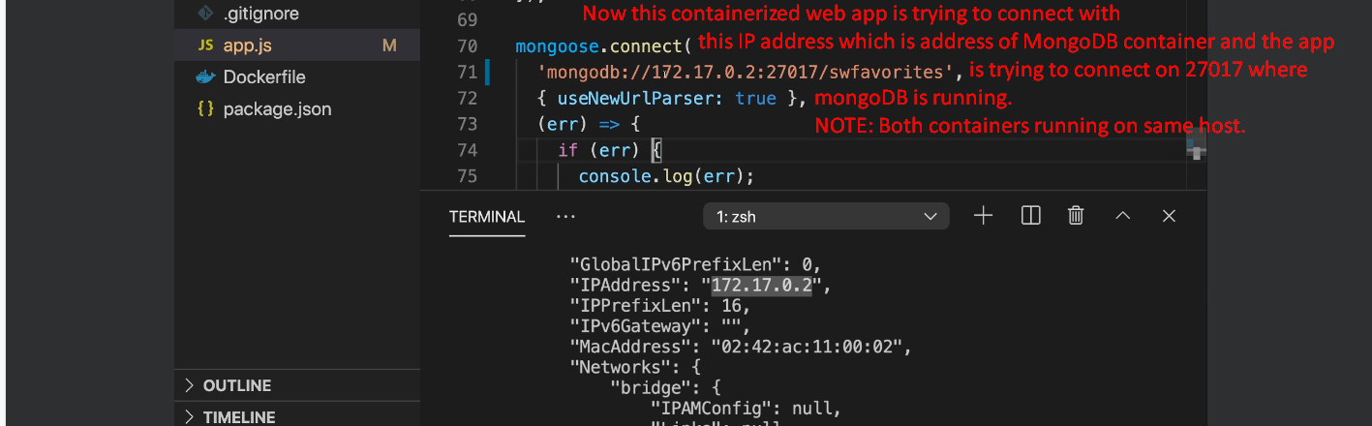

1. With this solution, the problem is that each time we need to change the source code in the containerized web app if the MongoDB Container’s address changes.
2. We will see an elegant solution in the next lecture.